SAP Exercise: 4

Step 1: Create New Customer

**Task** Create a new customer.

**Short Description** Use the SAP Easy Access Menu to create a new customer.

**Name (Position)** David Lopez (East Rep. Miami)

Submit the screen shot of the Change Customer: Sales Area Data (2.5 points)

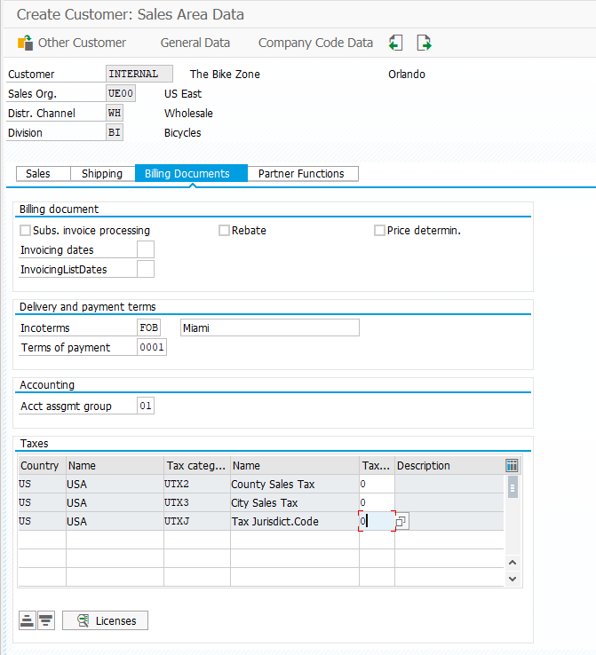

Submit the screen shot of the customer number generated (2.5 points)

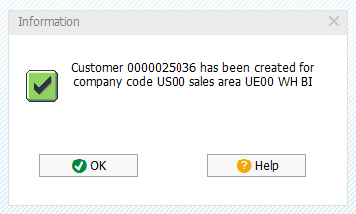

Step 2: Create Contact Person for Customer

**Task** Create a contact person for a customer.

**Short Description** Use the SAP Easy Access Menu to create a contact person.

**Name (Position)** Maria Diaz (Sales Person 1)

Customer: 25036

then submit the screen shot of Contact-Person Change (2.5 points),

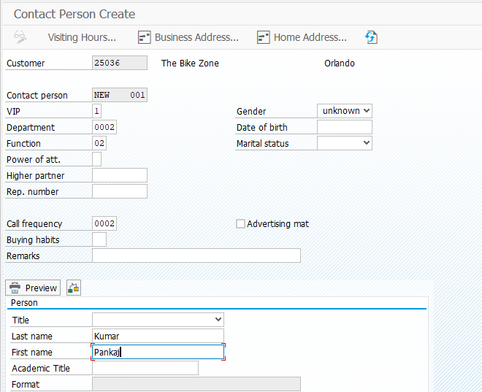

Step 3: Change Customer

**Task** Change a customer.

**Short Description** Use the SAP Easy Access Menu to change a customer.

**Name (Position)** Maria Diaz (Sales Person 1)

Submit the screen shot of the search for the contact person you created (2. 5 points)

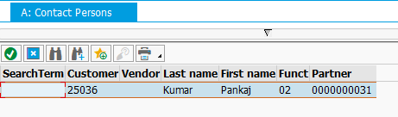

Step 4: Create Customer Inquiry

**Task** Create a customer inquiry.

**Short Description** Use the SAP Easy Access Menu to create a customer inquiry.

**Name (Position)** Matthias Dosch (Sales Person 2)

Change the order probabilities to **70**%, then click on the enter icon Okay to update the inquiry and note the new Expect.ord.val. Submit the screen shot showing the expected order value (5 points)

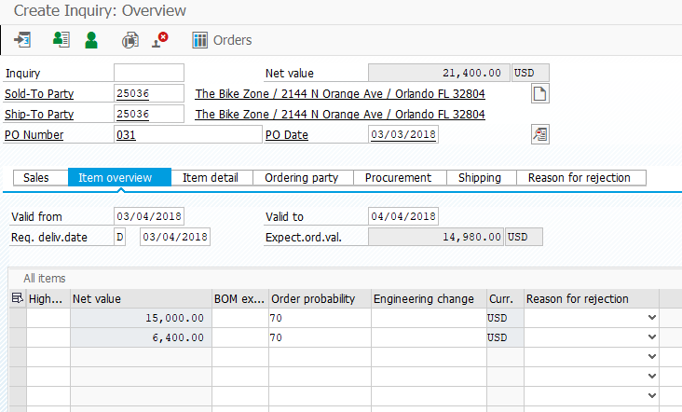

Step 5: Create Customer Quotation

**Task** Create a customer quotation.

**Short Description** Use the SAP Easy Access Menu to create a customer quotation.

**Name (Position)** David Lopez (East Rep. Miami)

Submit the screen shot showing the quotation with the 5% discount after the $50 discount per Deluxe Touring bike (5 points).

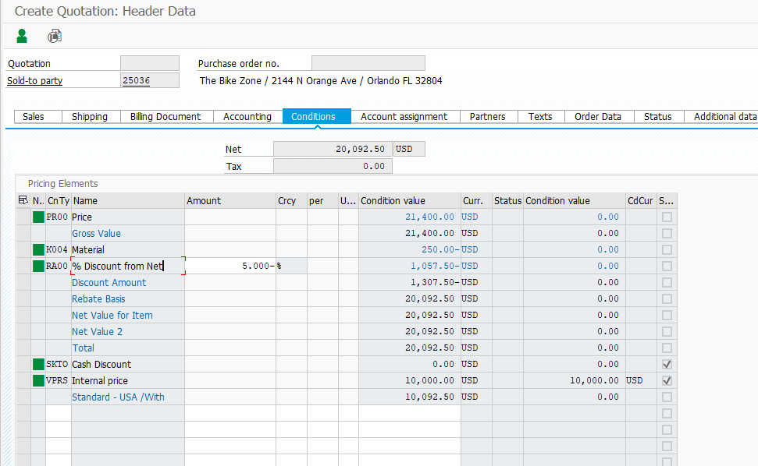

Step 6: Create Sales Order Referencing a Quotation

**Task** Create a sales order with reference to a quotation.

**Short Description** Use the SAP Easy Access Menu to create a sales order.

**Name (Position)** David Lopez (East Rep. Miami)

Submit the screen shot showing the Create Standard Order: Overview (2.5 points).

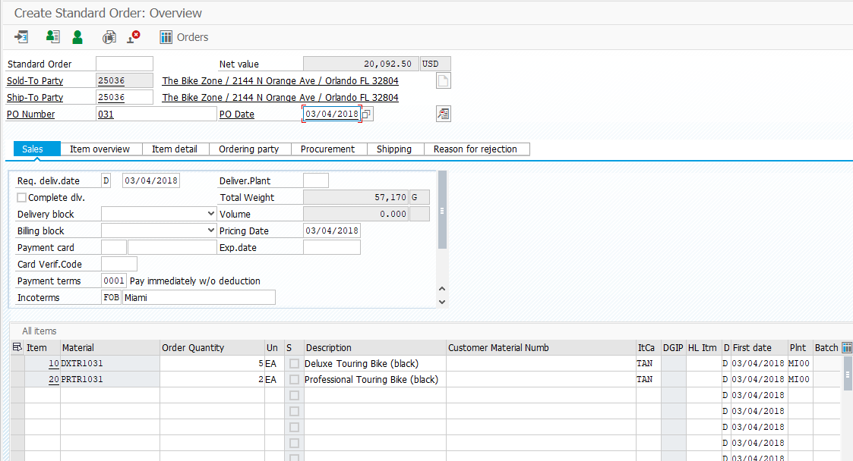

Step 7: Check Stock Status

**Task** Check the inventory.

**Short Description** Use the SAP Easy Access Menu to check the stock status.

**Name (Position)** David Lopez (East Rep. Miami)

Submit the screen shot showing the Stock Overview: Basic List (5 points)

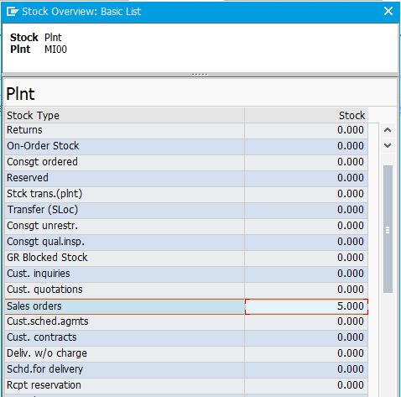

Step 8: Display Sales Order

**Task** Display a sales order.

**Short Description** Use the SAP Easy Access Menu to display a sales order.

**Name (Position)** Sandeep Das (Warehouse Supervisor)

Submit the screen shot showing the Pricing Elements (5 points).

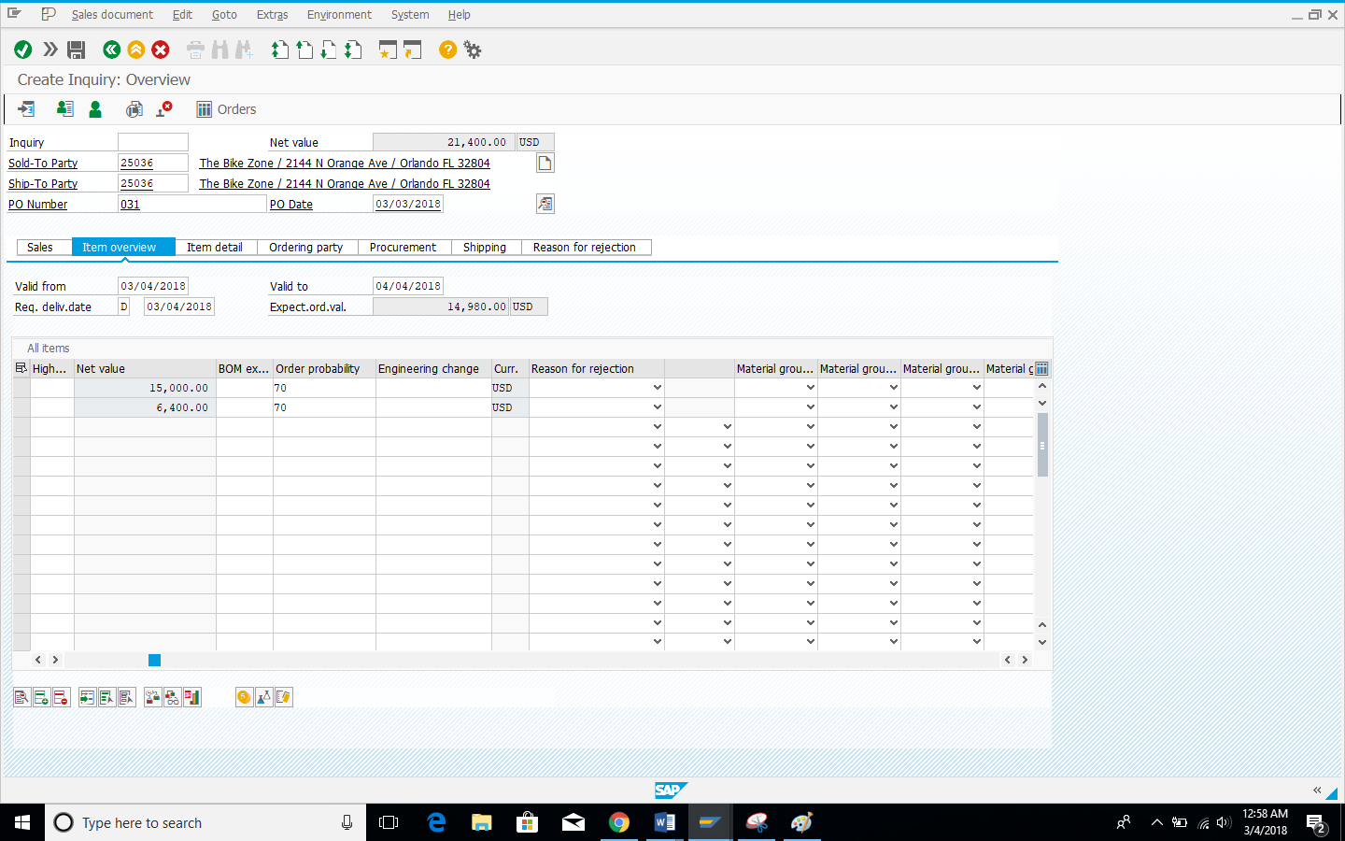

Step 9: Start Delivery Process

**Task** Start the delivery process.

**Short Description** Use the SAP Easy Access Menu to start the delivery process.

**Name (Position)** Sergey Petrov (Warehouse Employee)

Submit the screen shot showing the Screen of the Picking Tab (2.5 points).

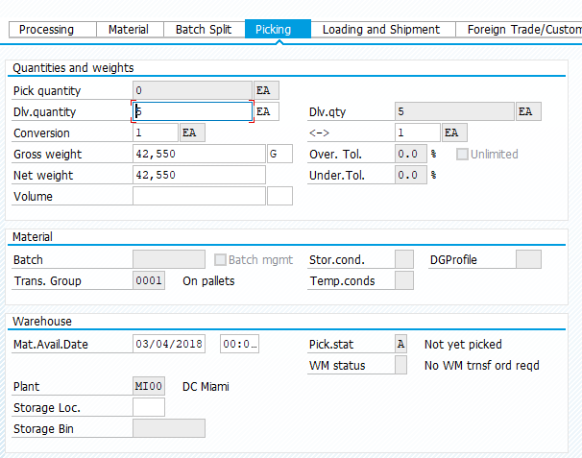

Step 10: Check Stock Status

**Task** Check the inventory.

**Short Description** Use the SAP Easy Access Menu to check the stock status.

**Name (Position)** Sergey Petrov (Warehouse Employee)

Submit the screen shot showing the Stock Overview: Basic List (2.5 points).

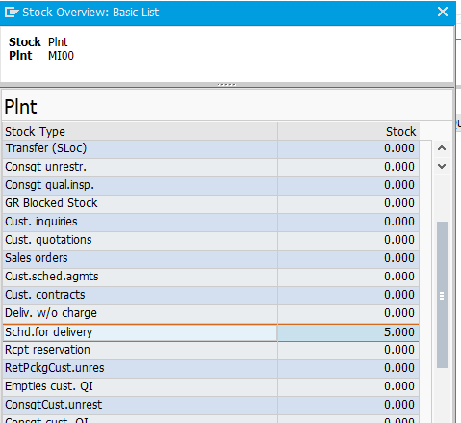

Step 11: Pick Materials on Delivery Note

**Task** Pick materials on delivery note.

**Short Description** Use the SAP Easy Access Menu to pick materials.

**Name (Position)** Sandeep Das (Warehouse Supervisor)

Submit the screen shot showing the Picking tab screen (2.5 points).

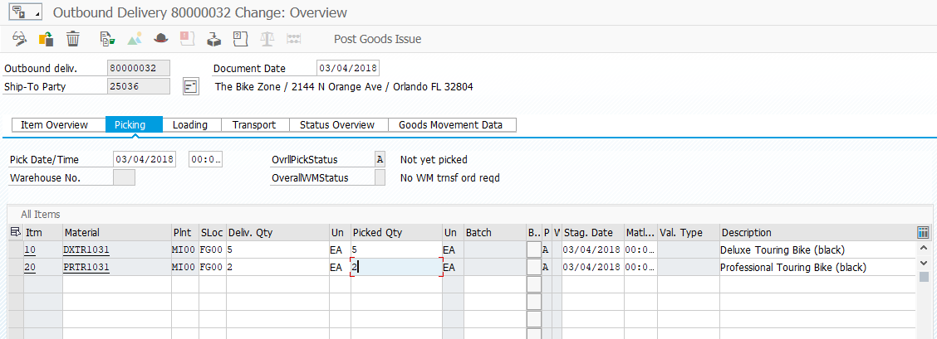

Step 12: Post Goods Issue

**Task** Post a goods issue.

**Short Description** Use the SAP Easy Access Menu to post a goods issue.

**Name (Position)** Sandeep Das (Warehouse Supervisor)

No screenshot asked.

Step 13: Check Stock Status

**Task** Check the inventory.

**Short Description** Use the SAP Easy Access Menu to check the stock status.

**Name (Position)** Sandeep Das (Warehouse Supervisor)

Submit the screen shot showing the Stock Overview Basic List (2.5 points).

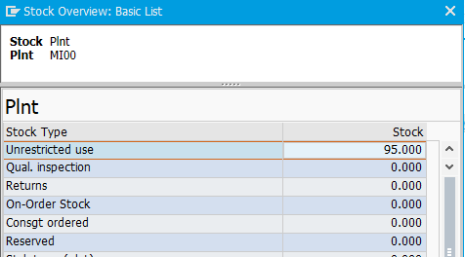

Step 14: Create Invoice for Customer

**Task** Create a billing document for a customer.

**Short Description** Use the SAP Easy Access Menu to create a customer billing document.

**Name (Position)** Stephanie Bernard (Billing Clerk)

Submit the screen shot showing the Invoice (F2) Create: Overview of Billing Items (5 points)

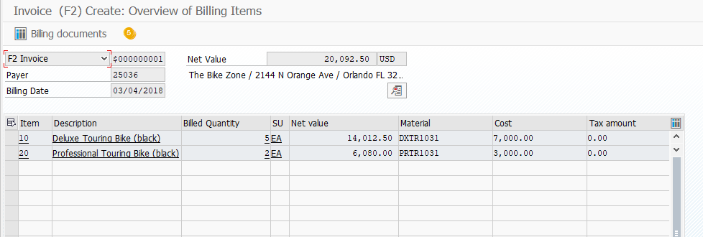

Step 15: Display Billing Document and Customer Invoice

**Task** Display a billing document and a customer invoice.

**Short Description** Use the SAP Easy Access Menu to display a billing document/customer invoice.

**Name (Position)** Stephanie Bernard (Billing Clerk)

Submit the Invoice (5 points)



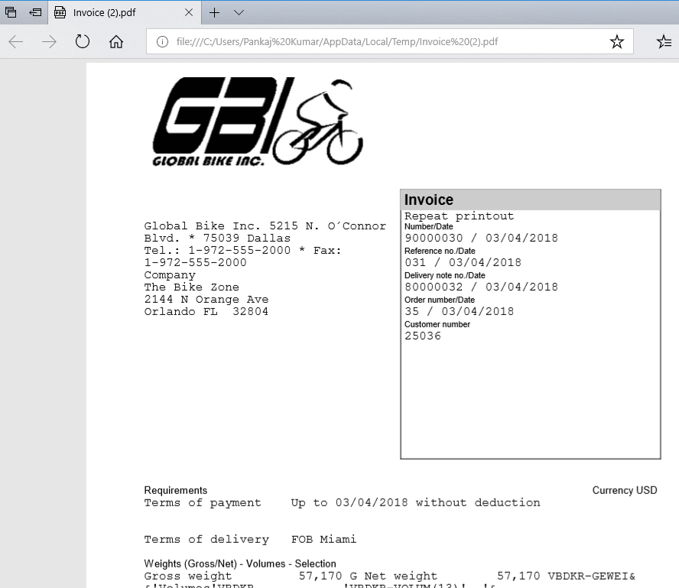

Step 16: Post Receipt of Customer Payment

**Task** Post a customer payment receipt.

**Short Description** Use the SAP Easy Access Menu to post a customer payment receipt.

**Name (Position)** Jamie Shamblin (Cost Accountant)

Submit the screen shot showing the Post Incoming Payments Process Open Items (2.5 points)

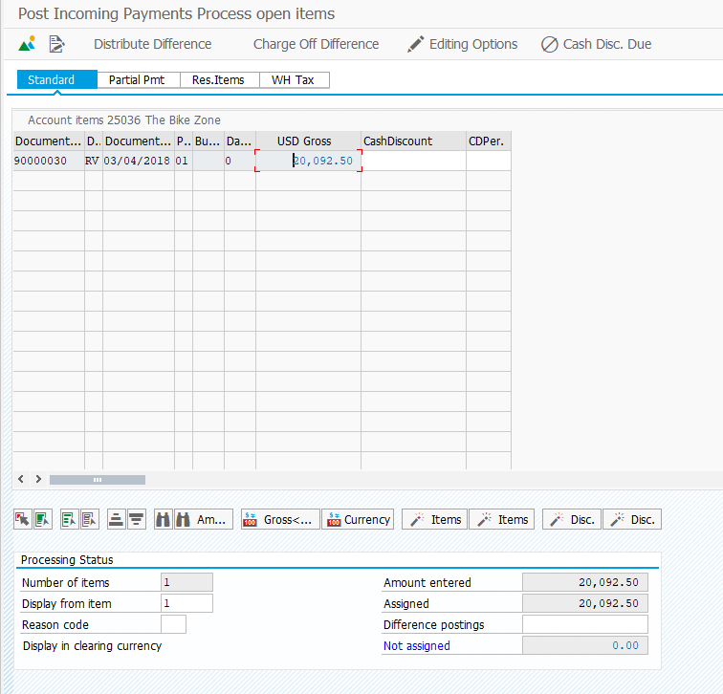

Step 17: Review Document Flow

**Task** Review the document flow.

**Short Description** Use the SAP Easy Access Menu to review the document flow.

**Name (Position)** David Lopez (East Rep. Miami)

Submit the screen shot showing the Document Flow Screen (5 points)

